**Activity starter and mail app**

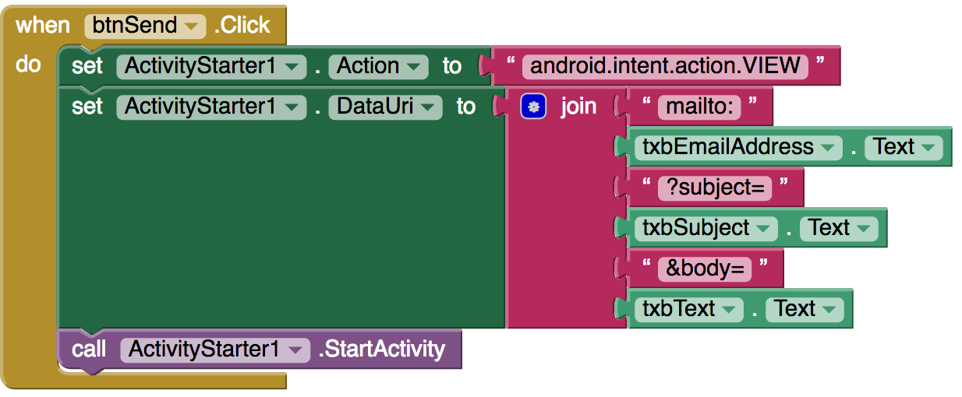

**Sharing component**

